**Tip Jar**

**User Guide**

By Jessica Journeycake

Table of Contents

Part 1: Tip Jar Consumer Application 3

# Tip Jar Home Setup

**Requirements:**

# iPhone

# 6 bins (bins can be boxes, reusable bags, really anything you're willing to put your recyclables/reusables in)

# Sticky notes or Paper & Tape

# Place your 6 Golden Bins around the house. I've included suggestions below. The 6 Golden Bins are color-coded based on the Consumer Goods companies that own the products you're reusing/recycling. All of the Golden Bins have an associated shape/icon to make labeling the bins around the house more convenient.

* Red Golden Bin (Kraft Heinz) - Suggested placement is in the kitchen.
* Orange Golden Bin (Unilever) - Suggested placement is in the bathroom.
* Yellow Golden Bin (To-Go Cups & Containers) - Suggested placement is in the kitchen.
* Green Golden Bin (Proctor & Gamble) - Suggested placement is in the bathroom.
* Blue Golden Bin (Coca-Cola) - Suggested placement is in the kitchen.
* Purple Golden Bin (Nestle) - Suggested placement is in the kitchen.

1. Label the bins accordingly, whether it's by color or shape/icon. I've included examples of my home setup below for 3 of the 6 Golden Bins.

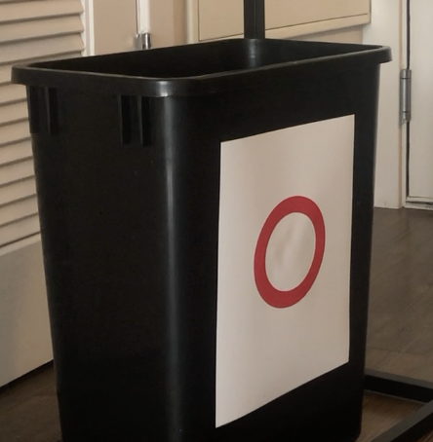

# Part 1: Tip Jar Consumer Application (iPhone only)

## Overview

1. From the **Log in** screen (screenshot below), click on "Guest User".

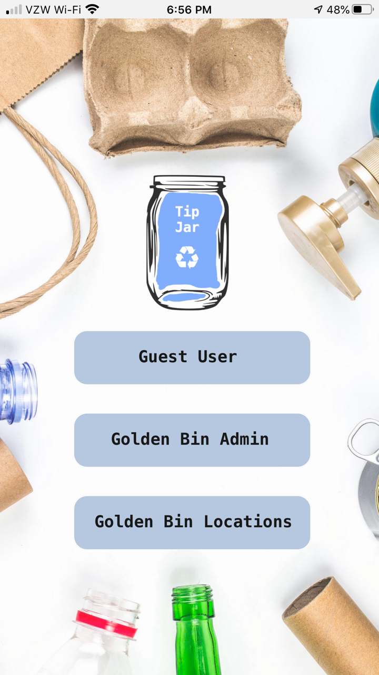

1. **Tip Jar (Home) tab:** This is the first screen that pops up after you click on "Guest User". This is your Tip Jar. Here you can see all of the tips you've collected from your Golden Bin drop-offs. You're also able to "Redeem Tips" (payment method on roadmap). Today, this button clears your Tip Jar for demo purposes.

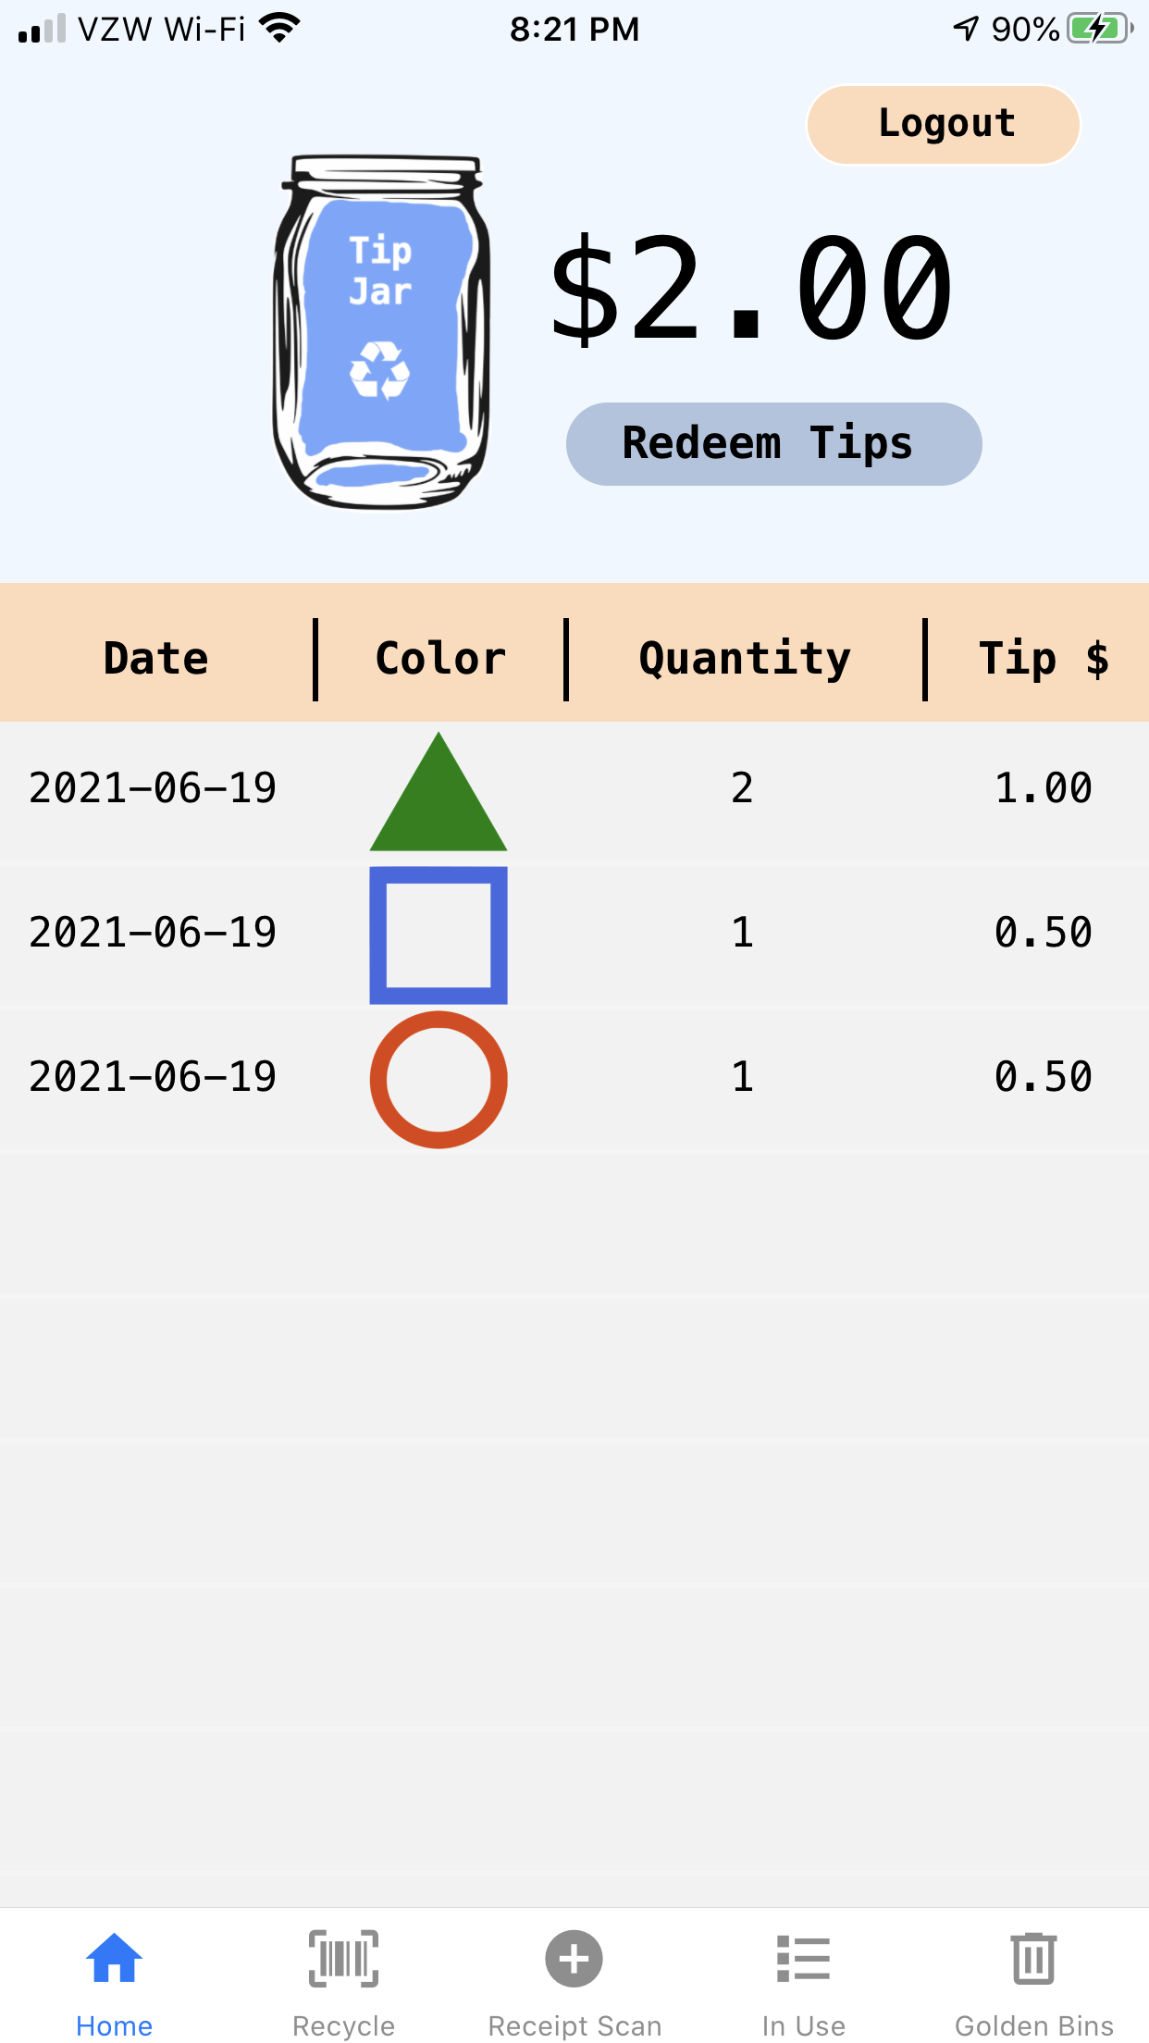

1. **Recycle tab:** This is where you scan the barcode on products that you are finished with and ready to recycle. Once you scan the empty container's barcode, Tip Jar gives you recycling instructions and instructs you to place your product in 1 of the 6 color-coded at-home recycling bins.

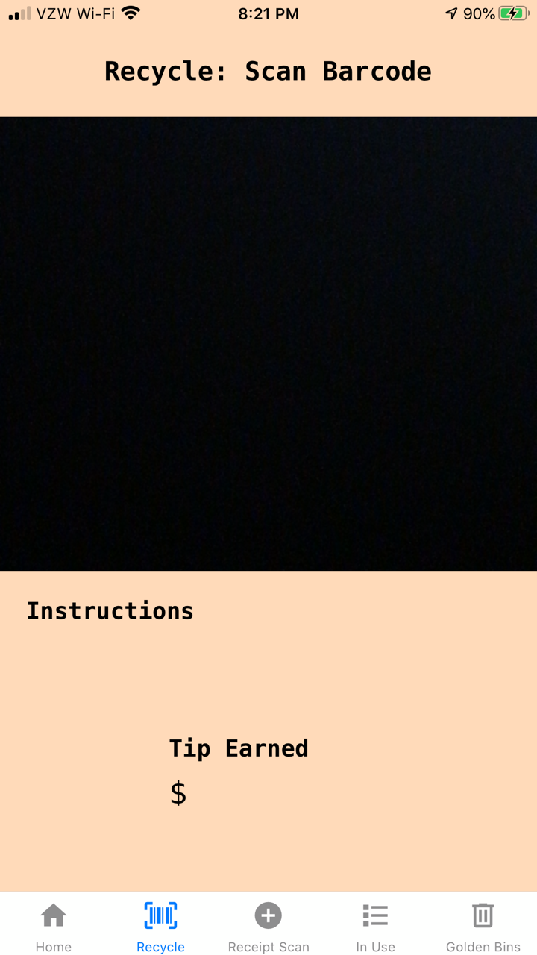

1. **Receipt Scan** tab: This is where you scan the Tip Jar QR code at the bottom of your receipt. I've included a sample receipt in the next section that you can scan using the app.

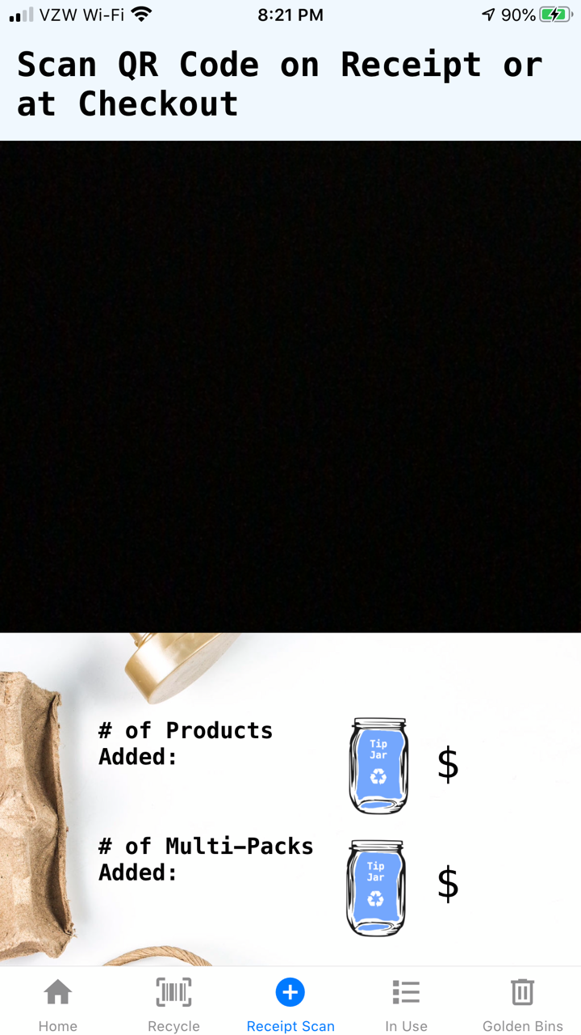

1. **In Use** tab: Once you scan the Tip Jar QR code on the receipt, the products registered with Tip Jar that are reusable/recyclable will appear in this tab. In the column at the far left, you can see the date of purchase for the item along with the Receipt ID.
   1. **Receipt Log:** The Receipt Log button located in the In Use tab is where you can view all of the Receipts (including the Receipt ID, Location, Date of Purchase, Number of Products In Use) you've scanned so far.
   2. **Multi-Pack Products:** Multi-Pack Products are products you purchase in packs of 4, 6, 8, 12, 16, etc. They are automatically recognized by Tip Jar when you scan the receipt Tip Jar QR code. For Multi-Pack Products, users continue to scan the individual product barcode rather than the Multi-Pack packaging barcode.

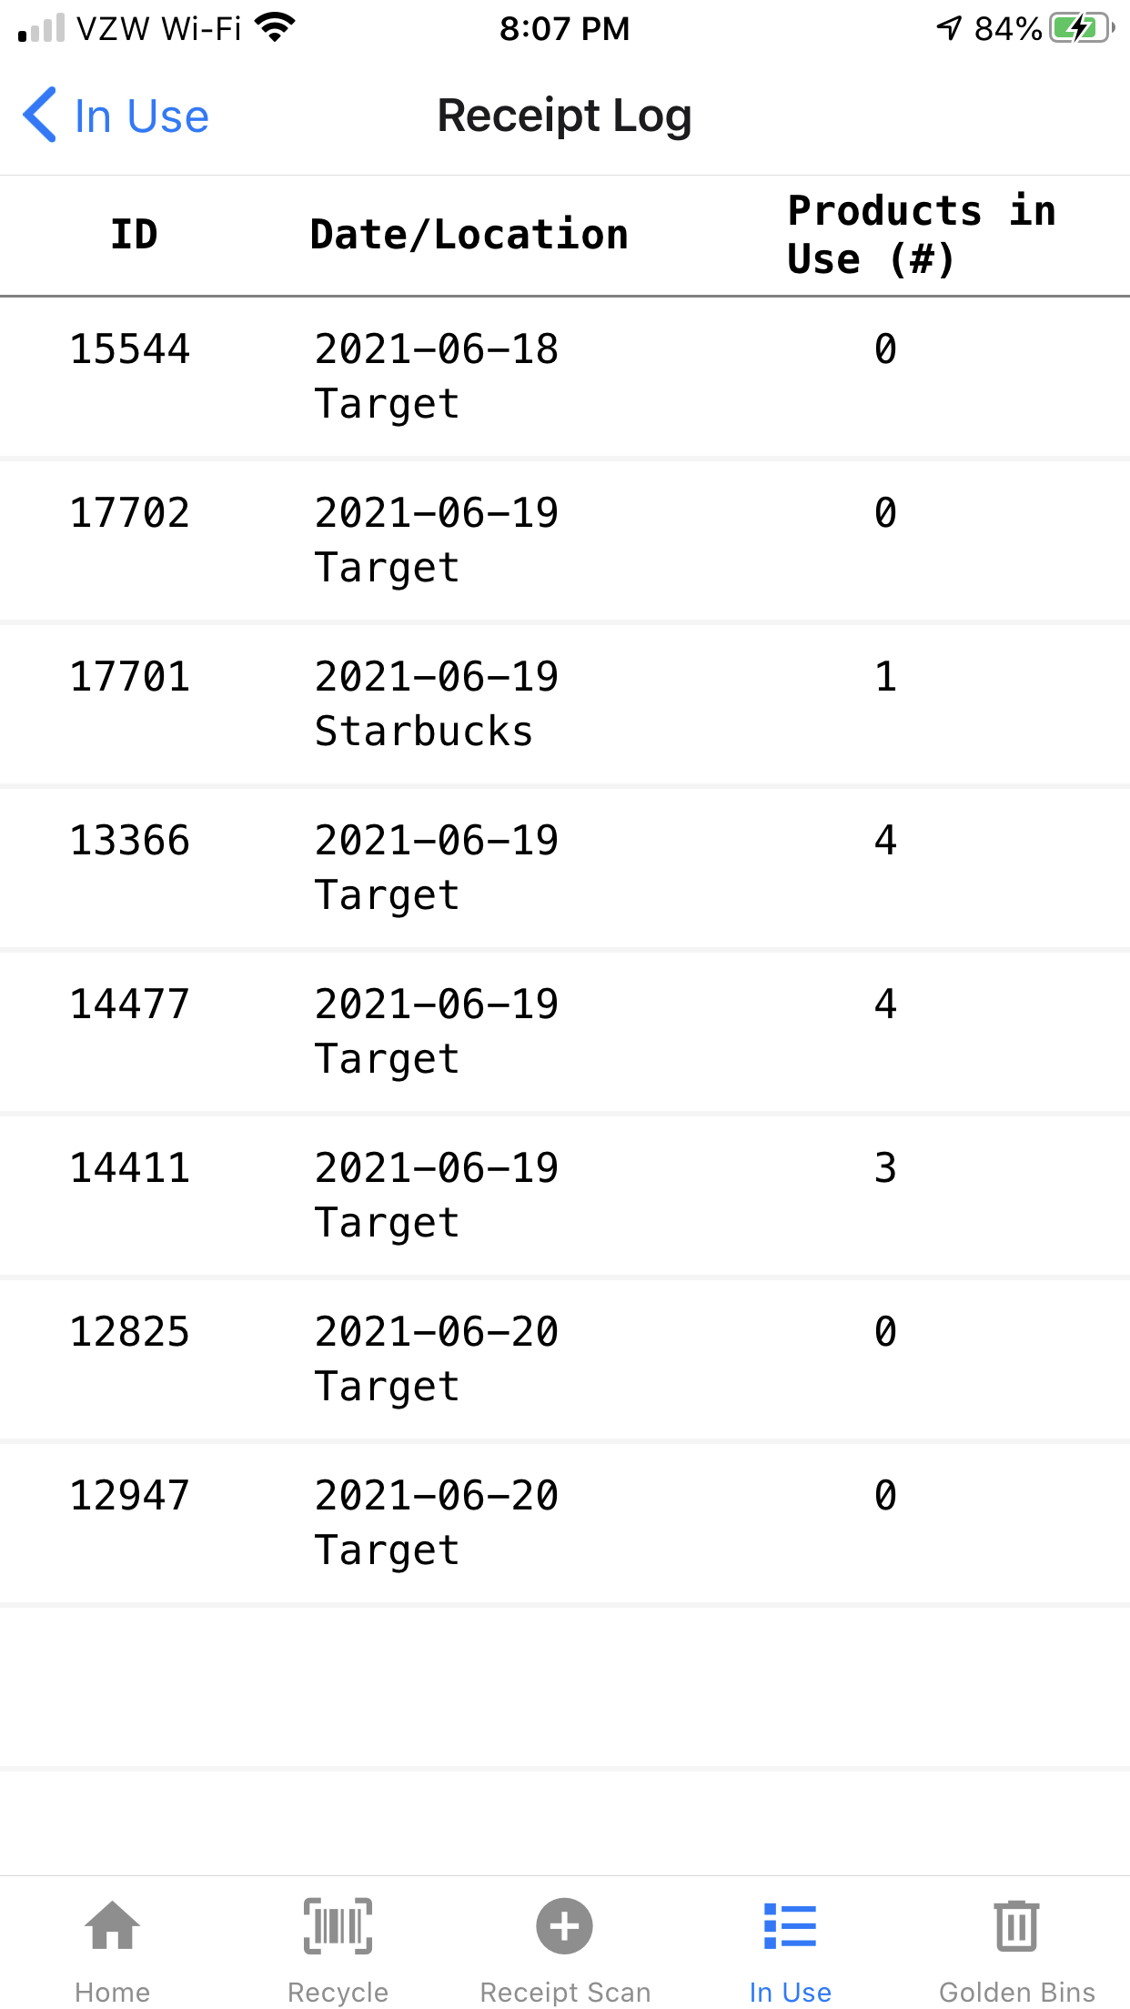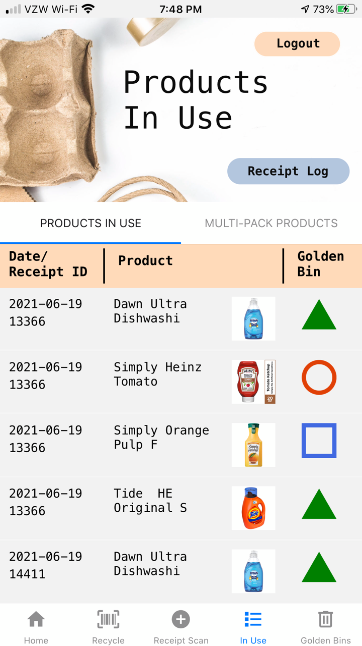

1. **Golden Bins** tab: There are 6 Golden Bins that you can place anywhere around your house. These bins are color-coded, with an additional shape/icon associated with each Golden Bin as well. Once the user is finished with their purchased product and has scanned the empty container product barcode in the **Recycle** tab, the user places the item/product into the associated Golden Bin. From there, Tip Jar automatically places the item into the "Virtual" Golden Bin. The Golden Bin tab is where you can view all 6 of your "Virtual" Golden Bins and the products you've recycled. The QR code located on each of the "Virtual" Golden Bin screens is scanned at the Golden Bin drop-off location when you are ready to discard your Golden Bin recyclables/reusables.

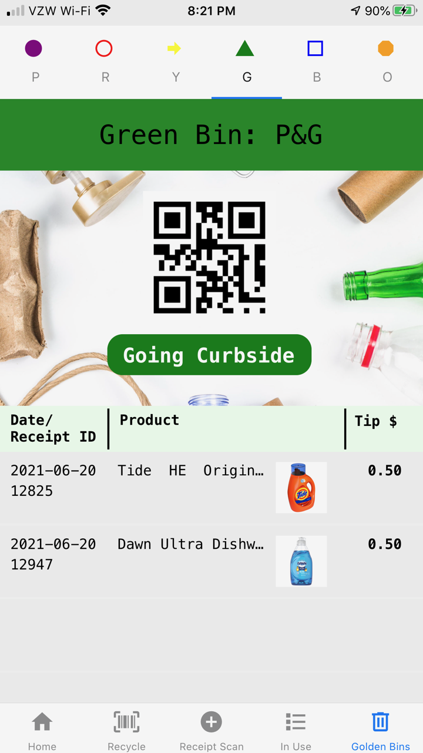

## Using the App

1. Scan the Tip Jar QR Code on Receipt
   1. Head to the Receipt Scan tab.
   2. Scan the QR Code on the Receipt below (fake receipt for demo purposes).

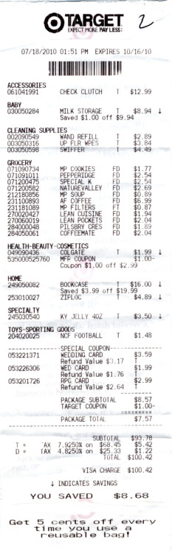

Scan the QR Code below

using the Tip Jar app!

**Receipt ID #12248**

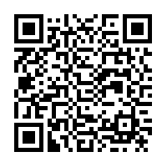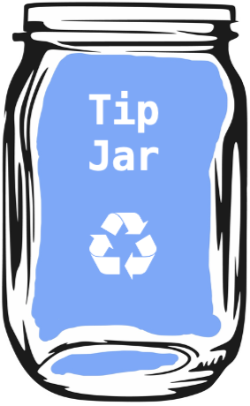

* 1. Tip Jar will output the number of products (in this case 4) on your receipt that have been identified as products registered with Tip Jar. Here, you also get to see the future tip you get to collect after heading to the Golden Bin drop-off!

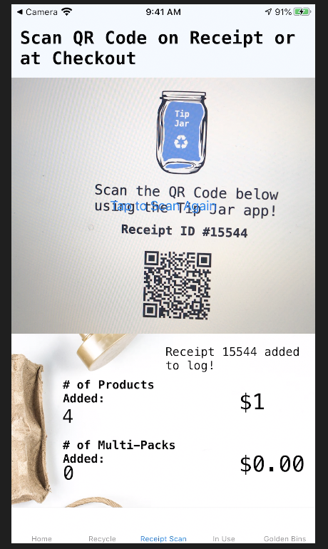

1. **View Products in Use & Receipt Log**
   1. Head to the In Use tab at the bottom of the Tip Jar app. Now, that you've scanned your receipt, Tip Jar has added those products to the Products In Use tab.



* 1. Click on the Receipt Log at the top right. Here you can see all of the Receipts that have been previously scanned.

1. **Recycle Products in Use** 
   1. Head to the Recycle tab.
   2. Below, I've included photos and barcodes for all of your Products in Use that are ready to be recycled.
   3. Scan the product barcodes below to identify which Golden Bin they should be placed in and view the recycling instructions.

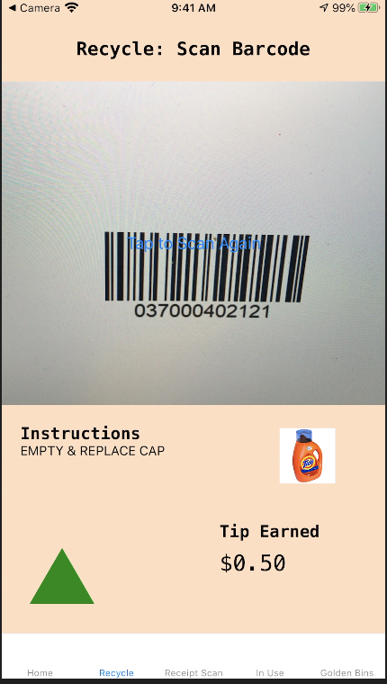

**Products in Use**

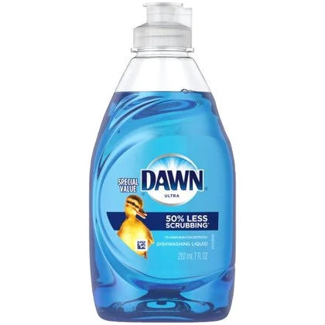

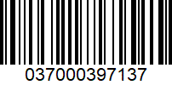

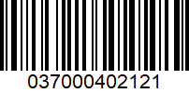

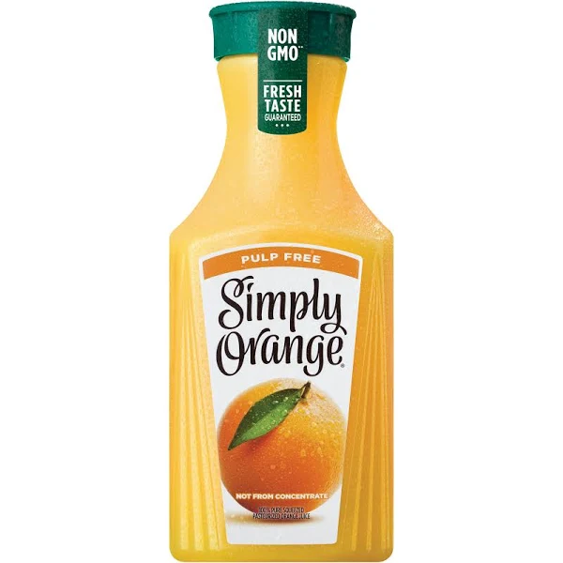

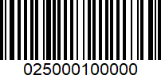

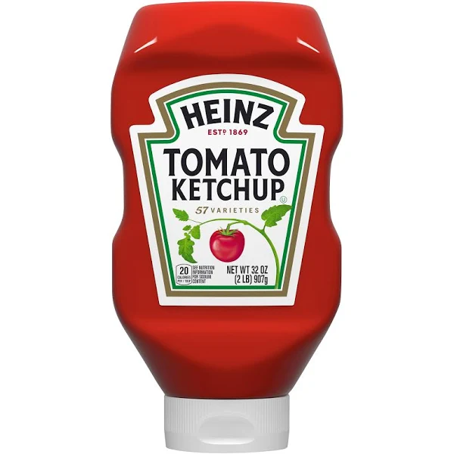

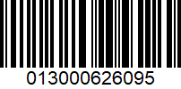

1. **View Golden Bin Discarded Recyclables/Reusables**
   1. Now that you've scanned the product barcodes for the products that are no longer in use, Tip Jar automatically places them in the "Virtual" Golden Bin that the Recycle tab instructs you to discard the product in.
   2. If you don't have any Golden Bin locations near you, feel free to click on the "Going Curbside" button and discard your Golden Bin products in your Curbside Pickup Recycling bin. While the tip won't be as great, we appreciate your sustainable efforts! This button can only be clicked once before all of your Golden Bin products for that specific Golden Bin will head to your Tip Jar. You will not be eligible for Golden Bin drop-off tips for those products until the next time you purchase these items and scan a new receipt.
   3. Take note of the QR Code at the top of each of the Golden Bin screens. When your Golden Bin is getting full and ready to be discarded, it will be time for you to head to one of the Golden Bin Drop-Off locations near you. At the drop-off location, you will first be required to scan this QR Code for the Golden Bin Administrator application to recognize it's you as well as to register the tips you're eligible for. Then, the Administrator application will require you to scan one item from your Golden Bin for verification purposes.



1. **Identify Golden Bin Drop-Off Locations Near You**
   1. From the Main screen, click on Golden Bin Locations. This screen is a "work in progress", but it at least gives you an idea of what it will look like once the work is completed!
2. Now head to Part 2 to configure the Admin Golden Bin Application to simulate a Golden Bin drop off and collect your Tip Jar tips!

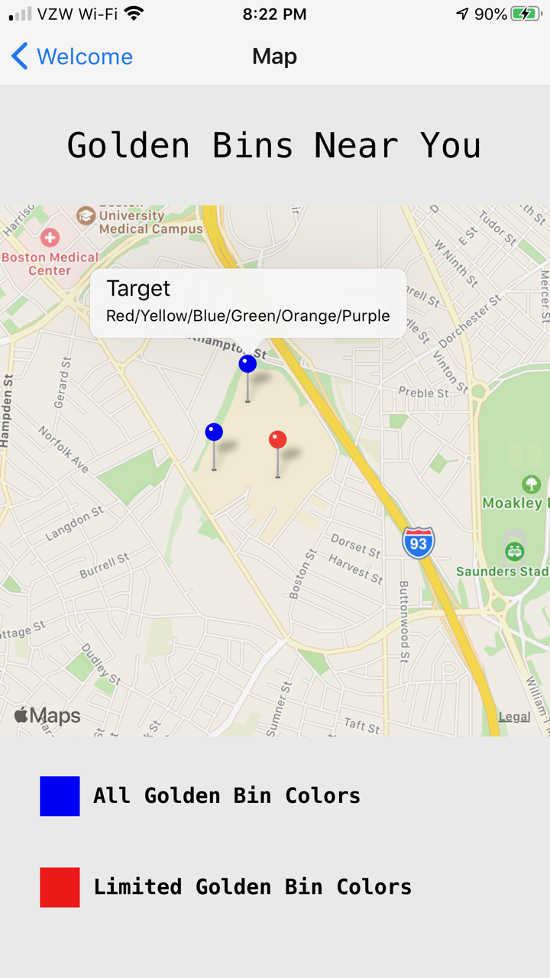

# Part 2 Golden Bin Administrator (iPad only)

1. Select Golden Bin Administrator from Login screen.
2. Select Golden Bin Color that you want displayed at the Golden Bin drop-off.

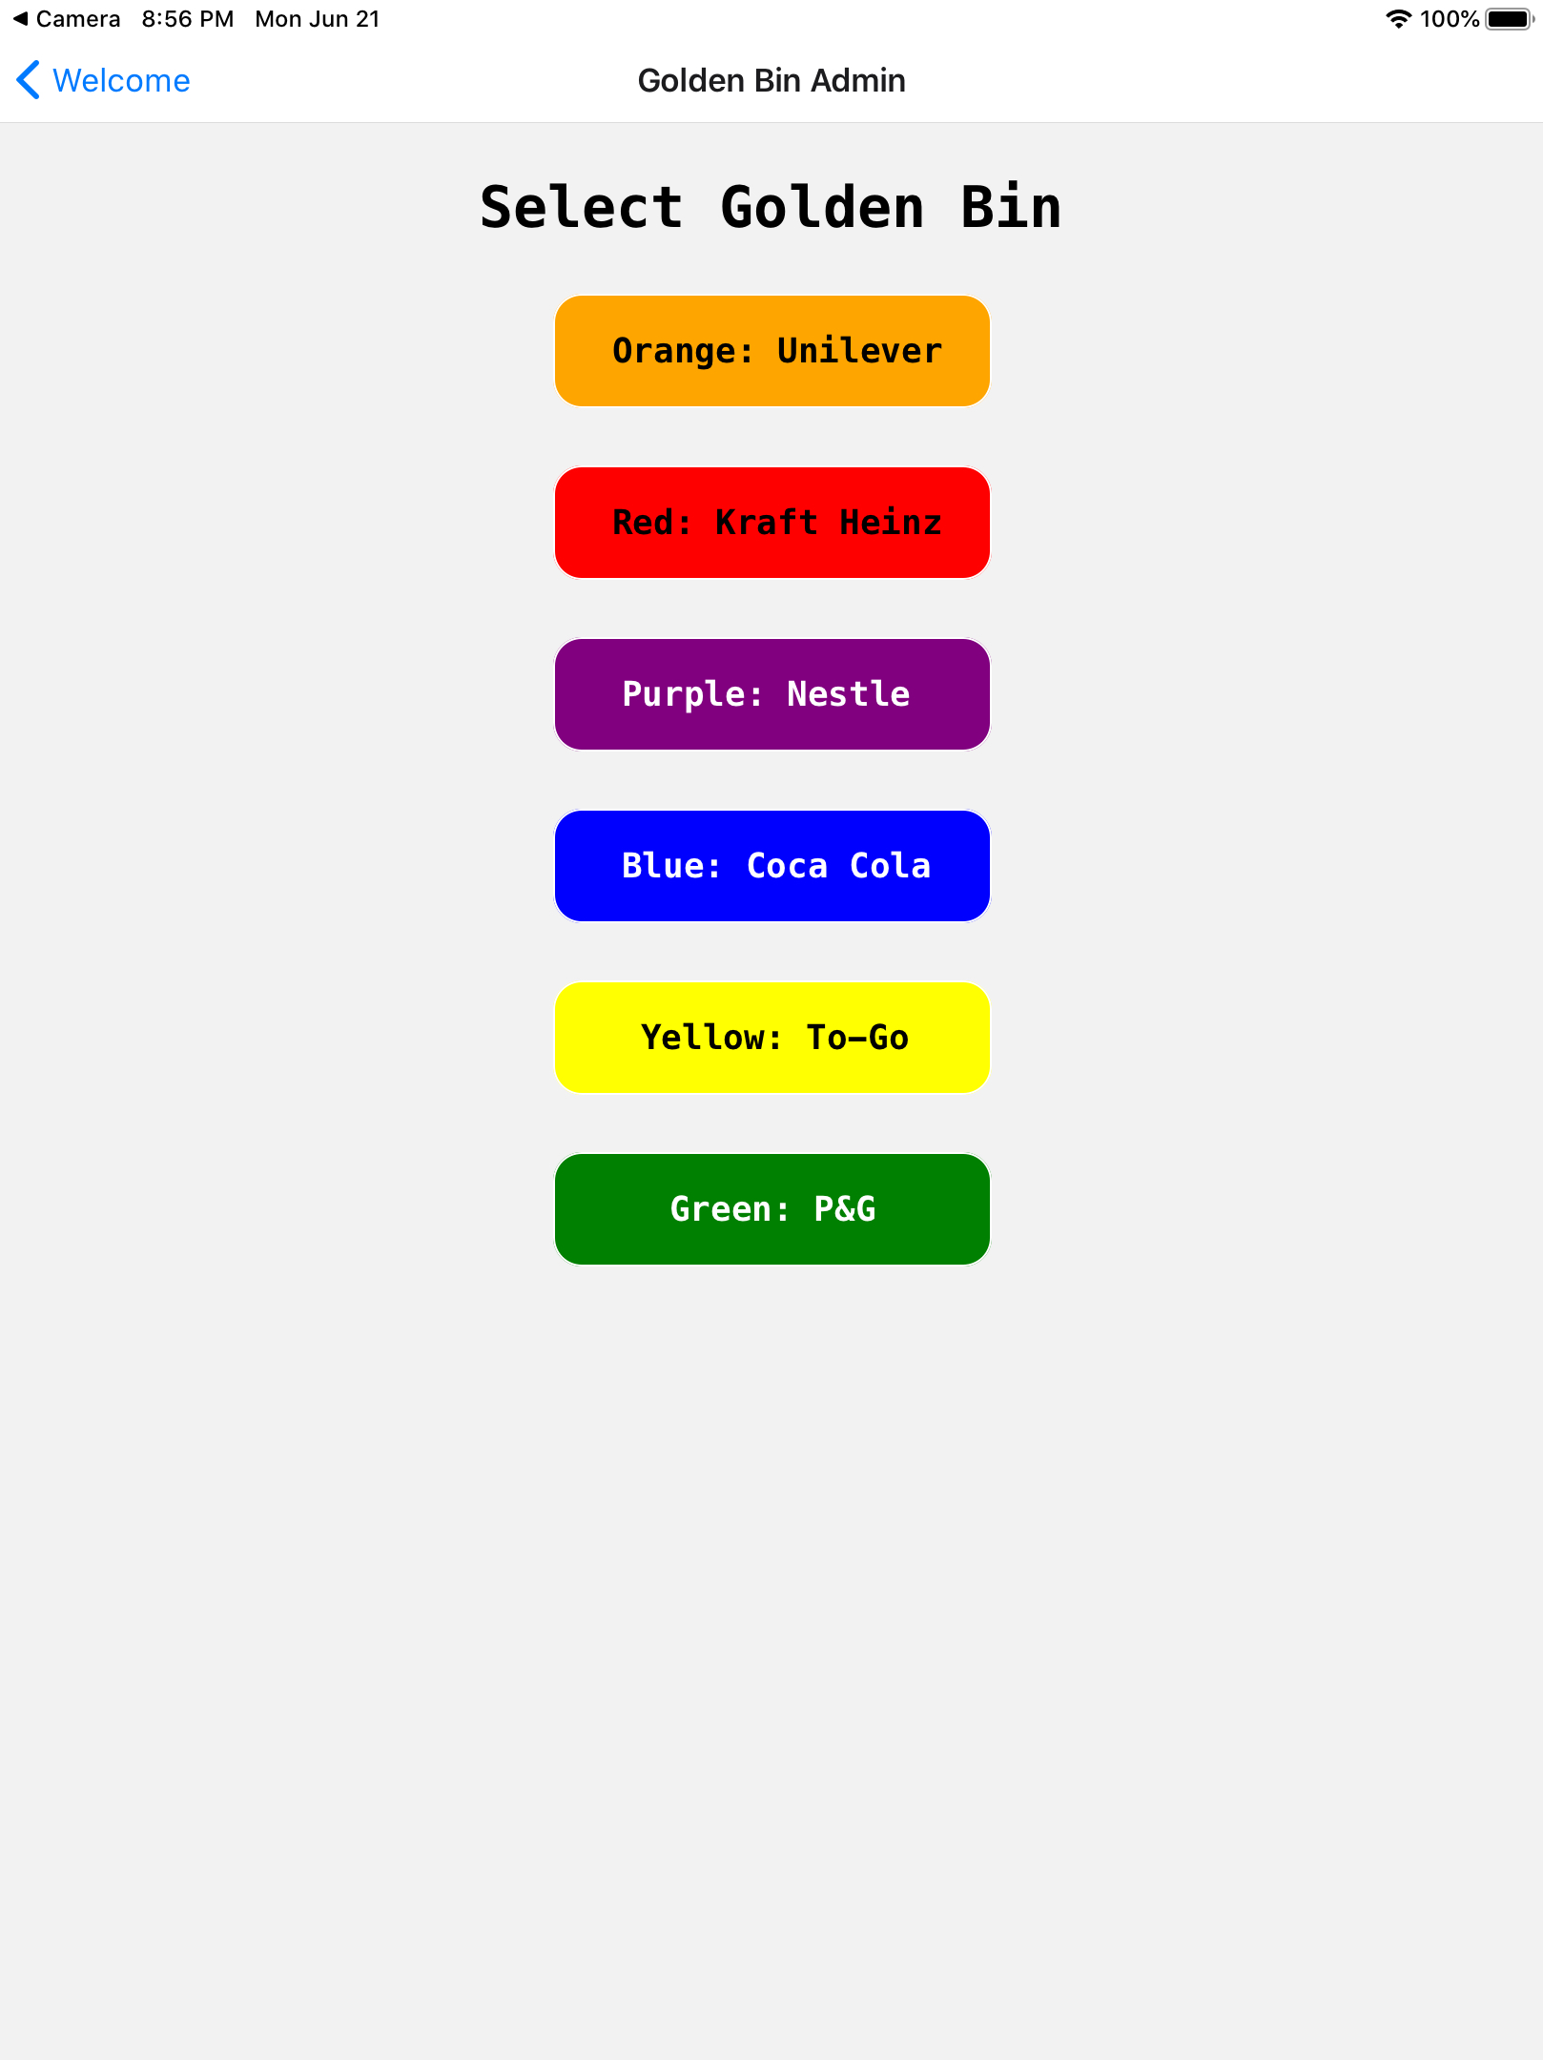

3. Step 1 at Golden Bin Drop-Off: Scan Golden Bin QR code from the Tip Jar Consumer iPhone application for the colored Golden Bin that you have displayed on the screen (Ex. Green Golden Bin QR code). Then select "Step 2".

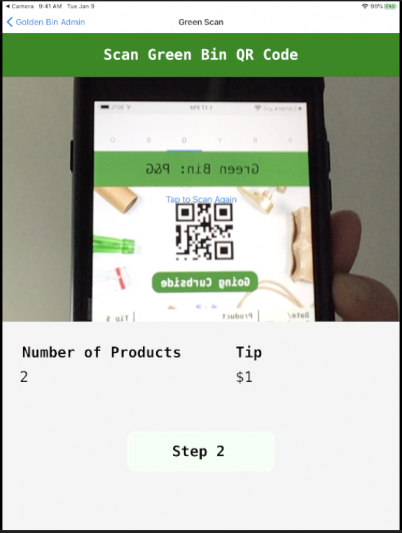

4. Step 2 at Golden Bin Drop-Off: Scan one product's barcode from the Green Golden Bin.

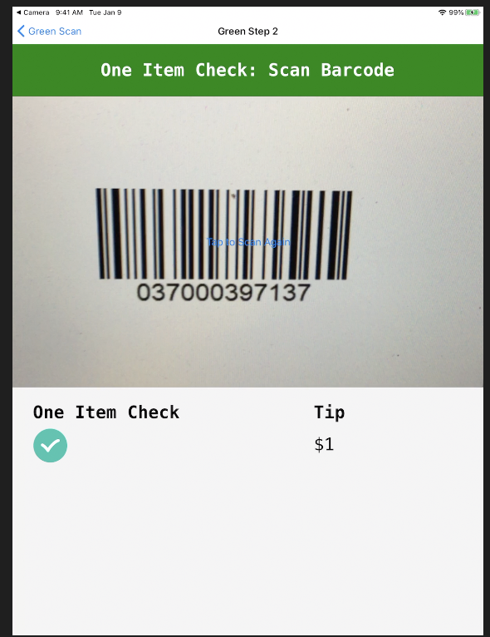

5. View the tips you've collected in your Tip Jar! Great work!

